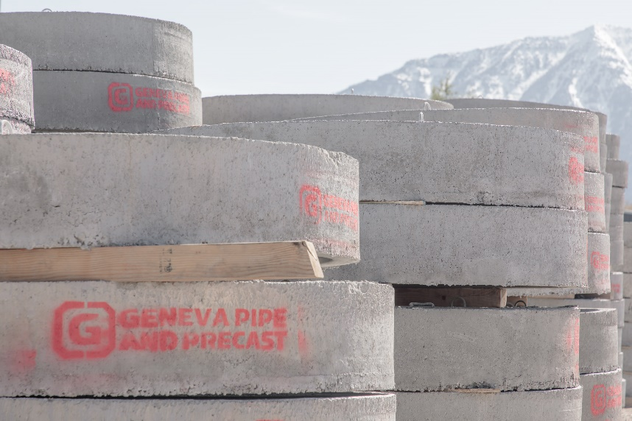
CURRENT OPENING
Fabricator
Location: Orem, Utah
Posting Date: 10/13/2021
Reports to: Fabrication supervisor
FLSA Status: Hourly
Close Date: 10/27

Get ready to grow with us.
Northwest Pipe Company is the nation’s leading manufacturer of water infrastructure products—and with over 50 years of experience, we’re just getting started! Our business is growing, and we’re looking for great people to grow with us. We’re immediately seeking a Fabricator to join our Geneva Pipe and Precast team in Orem, UT.
WE OFFER
- Medical, Dental, Vision, Life, AD&D Insurance (1st of month after hire)
- Paid Vacation, Holidays, and Sick Time-off
- Weekly Paycheck
- 401k Retirement Savings Plan with Employer Match
- Bonus Potential
- Tuition Reimbursement
- Safety Footwear AND Eyewear Voucher (day 1 of employment)
- On-Site Refreshments
- Employee Assistance Program
- Opportunities for Career Advancement
- Values-Driven Culture Committed to Diversity, Inclusion, and Safety

OUR VALUES
- Accountability is evident when we do what we say we are going to do and people accept responsibility for their actions. We do not point fingers and blame others. We own our actions.
- Commitment is not only promising to do something, but actually investing in the necessary effort and actions to make it happen.
- Teamwork is essential for competing in a challenging and constantly changing business environment. Working together across all job functions is critical to achieving our success.

ABOUT THE JOB
Tends fabricating machines such as cutoff saws, shears, rolls, brakes, presses, forming machines, welders, spinning machines, and punch, that cut, shape, and bend metal plates, sheets, tubes, and structures by performing the following duties:
ESSENTIAL FUNCTIONS & MAJOR RESPONSIBILITIES
- Operates Fab Shop and Machine Shop machinery and equipment. Reads job specifications to determine machine adjustments and material requirements.
- Sets stops or guides to specified length as indicated by scale, rule or template.
- Positions work piece against stops or aligns layout marks with die or blade.
- Pushes button or depresses pedal to activate machine.
- Observes machine operation to detect work piece defects or machine malfunction.
- Measures work piece dimensions to determine accuracy of machine operation.
- Removes burrs, sharp edges, rust, or scale from work piece.
- Performs minor machine maintenance such as oiling machines, dies, or work pieces.
- Sets up and performs maintenance on fab and machine shop machines and performs burning work.
- Operates any equipment needed to perform job,
- Performs related duties as assigned by supervision.

SECONDARY RESPONSIBILITIES:
- Will be called upon to Design, Fabricate, Build and possibly install items to help production be more efficient and safe.

KNOWLEDGE, SKILLS, ABILITIES:
- To perform this job successfully, an individual must be able to perform each essential duty satisfactorily. The requirements listed below are representative of the knowledge, skill, and/or ability required.
- Ability to add, subtract, multiply, and divide in all units of measure, using whole numbers, common fractions, and decimals. Ability to compute rate, ratio, and percent and to read and interpret metal rule.
- Skilled in fabrication techniques with steel.
- Ability to apply commonsense understanding to carry out detailed but uninvolved written or oral instructions.
- Ability to deal with problems involving a few concrete variables in standardized situations.

EDUCATION/EXPERIENCE
- High School diploma or general education degree (GED);
- 5 Years related experience and/or training; or equivalent combination of education and experience.

Reasonable accommodations may be made to enable individuals with disabilities to perform the essential functions.

TO APPLY
Sound like the job for you? Click here to apply online.
—
Our organization maintains a drug-free workplace. Except where prohibited by state law, all offers of employment are conditioned upon successful passing of a drug test and background check.
Northwest Pipe Company is committed to equal employment opportunity and affirmative action. Minorities, females, veterans, and individuals with disabilities are encouraged to apply.
Northwest Pipe Company reserves the right to close the position, with or without notice, if a qualified candidate is identified prior to the close date.

