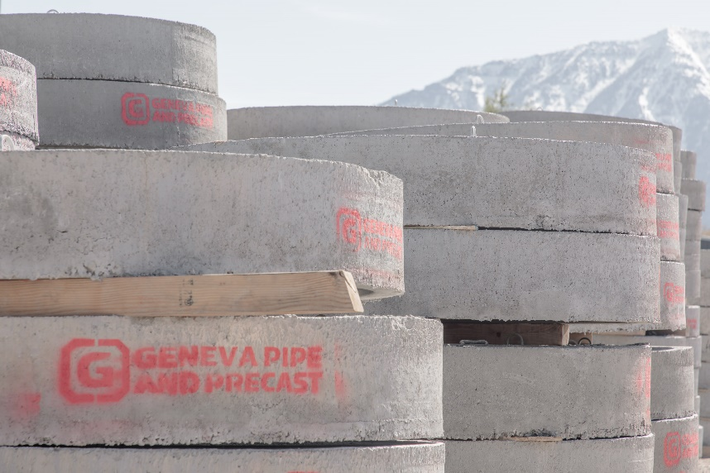
CURRENT OPENING
Buyer
Location: Orem, Utah
Posting Date: 4/12/2021
Reports to: Multi Site Operations Manager
FLSA Status: Exempt
Close Date: 5/12/2021 or Until filled*

Let’s get to work!
Interested in rewarding work experiences where you can thrive personally and professionally? How about peace of mind knowing that you are part of a valued team in a growing organization?
Come be part of our team!
ABOUT THE JOB
Responsible for procurement and the purchasing functions for all of the Geneva Pipe Plant Operations. Maintain professional relationships with a variety of vendors, in order to purchase products or services at the best possible prices. Maintain up to date vendor records and purchase order records, and follows all company policies and directives.

ESSENTIAL FUNCTIONS & MAJOR RESPONSIBILITIES
- Processes requisitions for MRO, RFQ and Raw Material items and administrates purchase orders.
- Researches products and vendors to optimize value and performance.
- Communicates and coordinates material and component delivery with appropriate departments.
- Checks back orders, expedites delivery of orders, maintain current status of purchase orders.
- Follow up on in-house processing of purchase orders to include goods receipts’ and invoice verification. Works with AP to resolve GR/IR Issues.
- Initiates and participates in problem identification and corrective action efforts in areas related to purchasing.
- Helps maintain and track inventory.
- Contract Management, Negotiations and Review.
- Familiar with Company procedures related to purchasing and executes daily business accordingly.
- Participates in appropriate training (SAP and track.net) and educational opportunities to stay abreast of changes.
- Supports Operations and Sales departments in administrative tasks as needed
- Completes special projects and reports as required.

EDUCATION/EXPERIENCE
- College and/or Purchasing experience of at least 2+ years for a manufacturing organization.
- Experience using SAP in a manufacturing environment preferred

Reasonable accommodations may be made to enable individuals with disabilities to perform the essential functions.

TO APPLY
Sound like the job for you? Click here to apply online.
—
Our organization maintains a drug-free workplace. Except where prohibited by state law, all offers of employment are conditioned upon successful passing of a drug test and background check.
Northwest Pipe Company is committed to equal employment opportunity and affirmative action. Minorities, females, veterans, and individuals with disabilities are encouraged to apply.
Northwest Pipe Company reserves the right to close the position, with or without notice, if a qualified candidate is identified prior to the close date.

