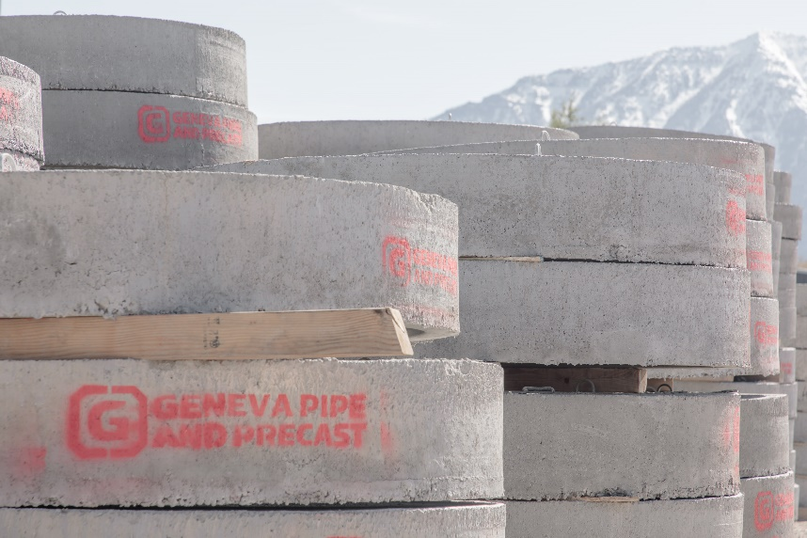
CURRENT OPENING
Forklift Operator
Location: Orem, Utah
Posting Date: 07/28/2020
Reports to: Plant Manager
FLSA Status: Hourly
Close Date: 08/28/2020*

Looking for a job with stable hours,
great benefits, and long-term security?
Join our fantastic team!
We offer a work environment that values safety and team input,
and provides opportunities to gain skills and grow your career.
ABOUT THE JOB
Under ongoing supervision, loads and unloads large concrete products and accessories onto flatbed trucks and trailers, and other materials required by the facility.

ESSENTIAL FUNCTIONS & MAJOR RESPONSIBILITIES
- Loads materials and equipment safely and efficiently on vehicles.
- Unloads materials and equipment safely and efficiently.
- Moves product, materials and equipment safely.
- Prepares vehicles and equipment for loads.
- Cuts materials in a safe manner to ensure safe transport of product and equipment
- Counts and marks all materials.
- Operates forklift, crane or other heavy equipment in a safe manner.
- Participates in all inventories.
- Performs other duties as needed by the Shipping Supervisor.
- Conducts safety audits.
- Ensures ISO procedures are performed correctly.
- Other duties may be assigned.

KNOWLEDGE, SKILLS & ABILITIES
- Ability to read preventive maintenance sheets and instruction manuals.
- Writes weekly preventive maintenance reports.
- Uses verbal communication skills on the radio and in working with Laborers, other drivers, and associates
from other departments.
- Reads pipe numbers and other markings, including fractions, tape measure, calculates peak loads and
rigging loads.
- Operates forklifts, spreader bar, grease gun and gas pump.

Full list of anticipated physical demands for this position and detail on our work environment is available on our application portal. Reasonable accommodations may be made to enable individuals with disabilities to perform the essential functions.

TO APPLY
Sound like the job for you? Click here to apply online.
—
Our organization maintains a drug-free workplace. Except where prohibited by state law, all offers of employment are conditioned upon successful passing of a drug test and background check.
Northwest Pipe Company is committed to equal employment opportunity and affirmative action. Minorities, females, veterans, and individuals with disabilities are encouraged to apply.
Northwest Pipe Company reserves the right to close the position, with or without notice, if a qualified candidate is identified prior to the close date.

